Sound Circle Center for Arts and Anthroposophy presents
The Art of Administration
and Leadership in Waldorf Schools

A unique professional development opportunity
for school faculty and administrative leaders, staff and key volunteers

Deepening Principles, Roles and Practices

Self-Administration and Collaboration

Phases of Administrative Development and Leadership

Our Dialogue with the World:

Marketing, Enrollment, Finance and Development

A New Imagination for Partnership Governance:

Administration, Board and Faculty Relationships

Presentations, Case Studies, Discussion Groups, Inner Development,
Artistic Work, Group Work

Whidbey Island Waldorf School, WA
July 19-24, 2020
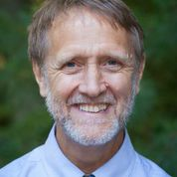
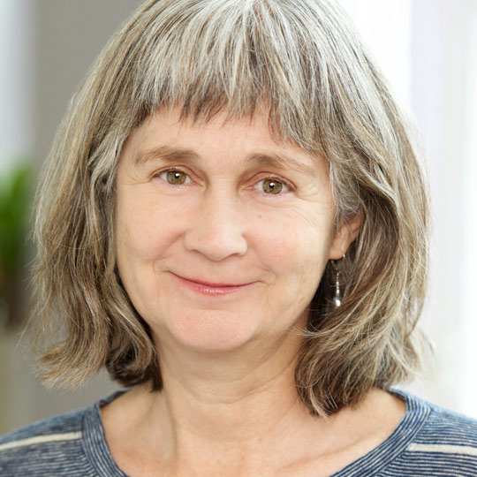

Marti Stewart Michael Soulé, MA
Administrative Director, Co-Director, LWS
City of Lakes Waldorf School Former Executive, AWSNA
Regional DANA Coordinator Program Director, Sound Circle Center
Board Chair, Novalis Institute School Advisor and Consultant

Registration due May 1
(registration after May 1 as space available)

For more information and to register go to www.LeadingwithSpirit.org

Leading with Spirit is a part-time two-year professional development program designed to support administrative leadership in Waldorf Schools and collaborative institutions. Full program information available at www.LeadingwithSpirit.org

