Sound Circle Center for Arts and Anthroposophy and Alkion Center present

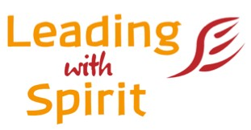
The Art of Administration
and Leadership in Waldorf Schools

A five-day intensive professional development opportunity
for school faculty, administrative leaders, staff, and key volunteers

Deepening Principles, Roles and Practices

Self-Administration and Collaboration

Phases of Administrative Development and Administrative Leadership

Our Dialogue with the World:

Marketing, Enrollment, Finance and Development

A New Imagination for Partnership:

Administration, Board and Faculty Relationships

Presentations, Case Studies, Discussion Groups,
Inner Development, Artistic Work, Group Work

July 5 -10, 2020
Alkion Center, Hawthorne Valley Waldorf School, Ghent, NY

Mara D. White Lisa Mahar
Director of School, Waldorf High School School Administrator, Monadnock
of Mass. Bay Waldorf School, (retired)
Initiator and Co-Founder, Administrators Founding Member of Administrators
Network of AWSNA (ANA) Network of AWSNA (ANA)
Past Sunbridge College Faculty Commissioner, NE Association of
Past AWSNA Leadership Council Member Schools and Colleges (NEASC)

Deadline for registration May 1
(Registration after May 1 as space available)
For more information and to register go to www.Leadingwithspirit.org

Leading with Spirit is a part-­‐time two-­‐year (3 summer) professional development program designed to support administrative leadership in Waldorf Schools and collaborative institutions. Full program information
available at www.LeadingwithSpirit.org or contact Lisamahar5@gmail.com

